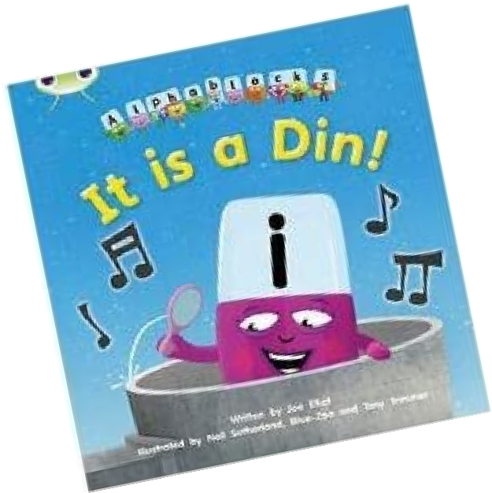
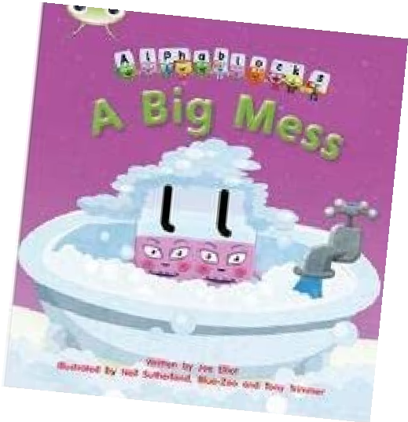
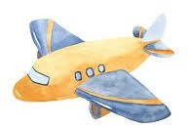
Foundation

Spring Term

Newsletter

Staff
The adults supporting your children this term - Kahlo Class Teachers
Mrs Corley
Mrs Jenkinson
Miss Thompson

Colder Months

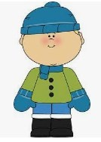
Please remember to send your child to school in the appropriate clothing for the weather that day (such as hats/gloves/scarves). On sunny days, please apply sun cream to your child before they come to school. Thank you



Fruit & Water

Just a reminder that it should be water in your child’s water bottle. Please save squash for lunchtime. Fruit is provided for our snack time.
On your child’s PE day, they may come to school in their PE kit and remain in it for the entire day. They do not need to bring uniform to change in to. As the children will be wearing their kit all day, please ensure that it is in line with our uniform policy. Navy blue and kit with logos on are not permitted. Please ensure that long hair is tied up and that earrings are not worn on PE days.
Reading
Thank you for your continued support with your child’s reading. Please continue to support your child to learn and consolidate their word cards (contained in the small plastic wallet).
Phonics books are designed to consolidate your child’s phonic knowledge. These words can be decoded by sounding out. i.e f-i-sh.
All children who read five times a week will be entered into a weekly draw to receive a golden ticket which can be used to choose a book in our vending machine!


PE Timetable


Our Topics for this term:
Literacy | Phase 3 and 4 Phonics  Reading  Letter/sound recognition. Writing captions and labels. Writing simple sentences. Model oral blending.  Exception words.  Daily writing activity sessions based on the texts covered.
Maths | Comparing quantities, using the language of more than, fewer than and equal.  Learn about the composition of numbers to ten. Counting up to 20.  Subitising
PSED | My emotions. Identities and Diversity.  Which stories are special and why?
PD | A range of activities to develop and improve gross and fine motor skills. Work on developing the correct pencil grip. Physical activities to develop core strength.
Expressive Art and Design | Learn and recite songs from around the world.  Identify pulse, rhythm and tempo within music.  Creating towns, buildings, vehicles and maps using a variety of media. Creating lovely creatures out of natural parts.
Understanding of the World | Weather and seasonal changes. Learning about the world round us using aps, atlas and artifacts.  Exploring the history of space flight.  Learning all about birds and their habitats.

Spring Term 1– Adventures Near and Far

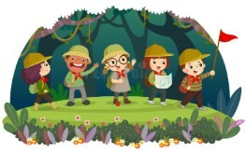
In this topic we will learn about the wider world around us, exploring different continents, countries, environments and cultures. We will also be exploring and learning about our local community and our place in it. We will enjoy listening to adventure stories like Going On A Bear Hunt and The Snail and The Whale and be inspired to produce their own writing.

Spring Term 2– The Skies Above My Eyes

In this topic we will ask the children to look up and
explore the wonderful world above our eyes. From learning about the history of flight and exploring modern technology as well as understanding better, the natural world in our skies from weather to birds.


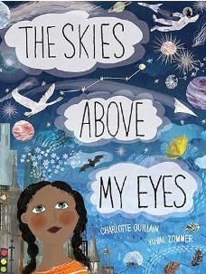


Homework
If you would like to contact a member of staff, please phone or email your class teacher via the contacts on the website. Kind regards, the Foundation Team
Reading—your child will bring home words to read by
sight, please practise at least 5 times a week.

