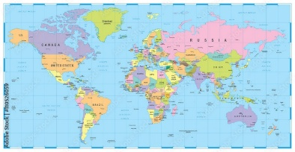
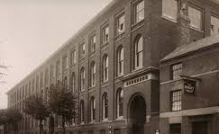



Year 3 and 4 Spring Term Newsletter
Staff

The adults supporting your children this term are:
Mrs Burt
Mr Cramp – Gaudi Class Teacher
Mrs Potter
Mrs Rajpara – Chanel Class Teacher
Mr Roper – Newton Class Teacher/Phase Leader
Mrs Sheppard-Booles
Mrs Zielonka
Curriculum

English | Aladdin and the Enchanted Lamp
Maths | Year 3: Multiplication and division. Length and perimeter. Fractions. Mass. Capacity  Year 4: Multiplication and division. Length and perimeter. Fractions. Decimals
Science | Eating and digestion. States of matter
Art | Exploring still life
D&T | British inventors
RE | What kind of world would Jesus want? Why do Christians call the day Jesus died ‘Good Friday’?
Music | Rhythm. Pitch
PE | Dance. Netball. Cricket
Computing | Animation. Branching databases
MFL | Spanish—What is the date? To know action verbs
PSHE | Diversity & communities. Drug education.  No Outsiders books: ‘The way back home’ ‘Dogs don’t do ballet’
History/Geography | In the Desert. Victorian Hinckley. Countries of the World
Commando Joe’s | Kira Salak

Fruit & Water


Children are encouraged to bring a sports cap suction bottle to school each morning, filled with water.
Please save squash for lunchtime. They are also invited to bring fruit as a snack for morning break.

Homework
Homework needs to be handed in by Friday each week.

Spellings
Your child will be given a list of 10 spellings (based on various year 3 or year 4 spelling rules) on Friday each week. We do a spelling test in school every Friday.

Reading
Reading continues to be an extremely important area of your child’s learning. We encourage children to read a range of texts to expand their comprehension and vocabulary. Your child is expected to read at home AT LEAST 5 TIMES PER WEEK. These reads should be recorded (and signed by an adult) in their reading diary. To encourage reading, we will continue to award reading raffle tickets for a chance to win a book from our reading vending machine.

They can access their Bug Club books, and do quizzes for their Bug Club books, via www.activelearnprimary.co.uk. This is in addition to our homework expectations.

Times Tables
Your child has a times tables homework book. Each week, they will be asked to complete a page (based on a specific times tables fact). We also recommend that your child access Times Tables Rock Stars to practise their times tables knowledge.
Children can also log onto DoodleMaths. Each month, there is a prize for the Doodle Maths star in each year group.

PE Timetable




Chanel | Monday | Friday
Newton | Monday | Friday
Gaudi | Monday | Friday

On your child’s PE day, or a swimming day (this is on a Tuesday) they may come to school in their PE kit and remain in it for the entire day. They do not need to bring uniform to change in to. As the children will be wearing their kit all day, please ensure that it is in line with our uniform policy. Navy blue joggers/leggings are not permitted. Please ensure that long hair is tied up and that earrings are not worn on PE days

Colder Months
Please remember to send your child to school in the appropriate clothing for the weather that day (such as hats/gloves/ scarves). All clothing should be named. On sunny days, please apply sun cream to your child before they come to school.

Thank you.
If you would like to contact a member of staff, please phone or email the office who will readily pass on your query.
Kind regards, the Year 3 and 4 Team

